THIS WORKS (but the following after it does not work though it brings back data )
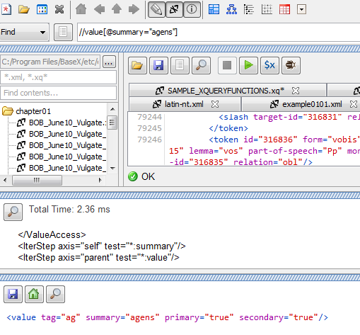IT SHOULD GIVE THE ABOVE ANSWER

This is the right data but it is now bringing back way more than it should
But the only difference is that specification at the front

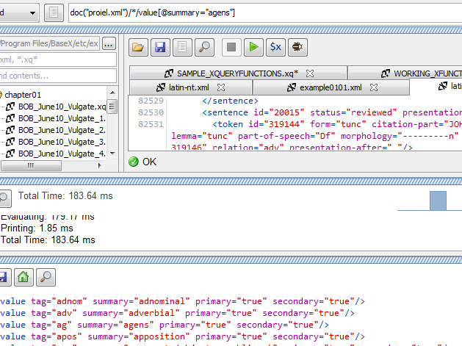
The third line is the right answer but a whole lot more has been included.

