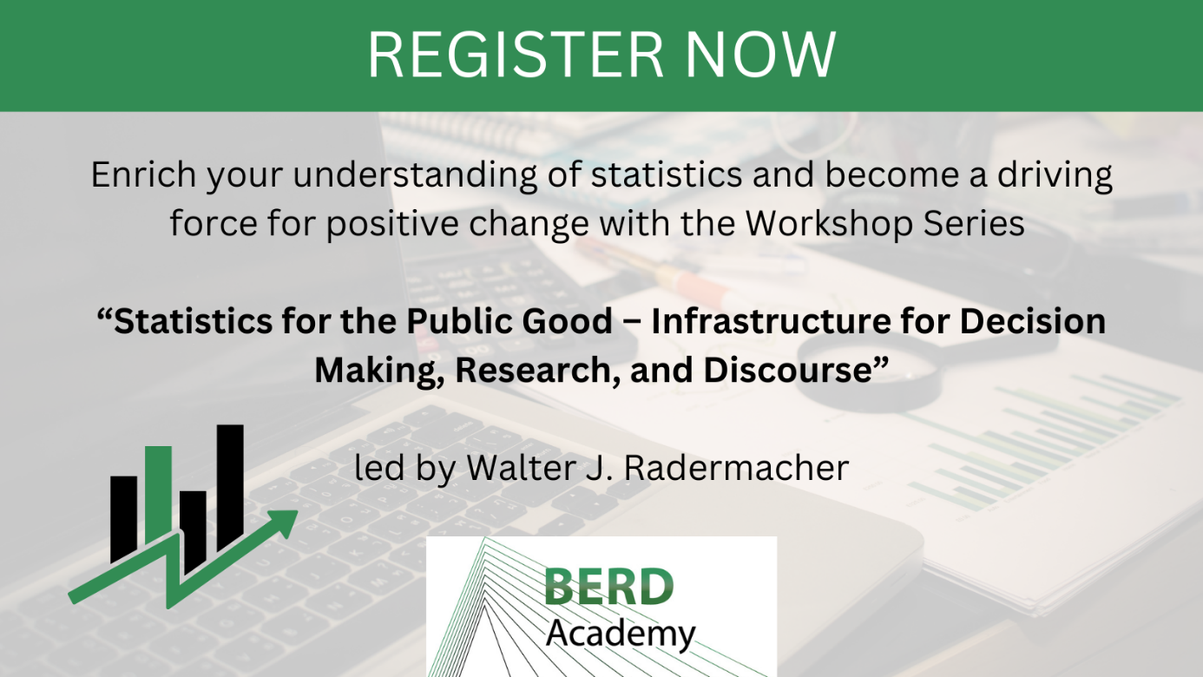

Join us for a transformative workshop series that will equip you with the knowledge and skills to navigate the intricate landscape of data culture, ethical considerations, and policy implications.

Registration is done separately for each session. By taking part in this workshop, you will also receive access to the introductory videos of "The Public Good Statistics: A Reflective Introduction."

📈 Session 1: The Public Good Statistics - Let's talk about Data Culture!

📆 Tuesday, October 10, 2023
⏰ 9 am to 5 pm (lunch break from 12 to 2 pm)
📍 LMU Munich

Why Discuss Data Culture?
Public statistics is more than just the application of statistical methods. In this workshop, you will become familiar with how different societal interests influence public statistics and how, in turn, information shapes public discourse.

Throughout the workshop, you will develop a fundamental understanding of data literacy and data culture, catering not only to data professionals but also to all users of data and statistics. We will explore the questions of how conventions are at the heart of the co-production of statistics and society — and what decision-making processes drive them. We will approach the answer by taking concrete case studies and questions from the current political landscape and trying to answer them with the best possible quantifications.

🔗 Register here: https://www.berd-nfdi.de/berd-academy/statpubgood1-dataculture-2023/

💡 Session 2: Values, Ethics, and What They Mean for Quality

📆 Wednesday, October 11, 2023
⏰ 9 am to 5 pm (lunch break from 12 to 2 pm)
📍 LMU Munich

How are Values and Ethics Linked to Data Quality?
As with other products, public statistics aims to optimize the design (form) of the use (function) of the products (“form follows function”). In this respect, it is about more than just the application of statistical methods. Rather, the focus must be on the questions that society wants to have answered with solid statistics for its current, pressing, and conflict-laden issues. Other aspects then play a role here, namely whether politics values and finances this infrastructure, whether corresponding data literacy is available in the population at large, and so on.

In this workshop, you will gain a basic understanding of why ethics and values play such an important role when using data. You will get to know different ethical principles and discuss if they are still up-to-date with current developments and new data sources. By doing so, we will explore the relationship between quality of information, integrity, and governance.

🔗 Register here: https://www.berd-nfdi.de/berd-academy/statpubgood2-valuesethics-2023/

📊 Session 3: Data 4 Policy: The Evolution from Statistical to Data

📆 Thursday, October 12, 2023
⏰ 9 am to 5 pm (lunch break from 12 to 2 pm)
📍 LMU Munich

Let’s discuss the future of data, statistics, and society
New data sources and data science methods open up substantial opportunities for research and for improving statistics. However, the integration of traditional and newer methods requires more than the merging of methodology and technology.

In this workshop, you will discuss the differences between data-driven and question-driven approaches. We will explore in which places of society data plays an important role and how it is regulated. By this, we will expand on the triangle of data, facts, and policy. Let’s discuss the future of data and society!

🔗 Register here: https://www.berd-nfdi.de/berd-academy/statpubgood3-data4policy-2023/

